**Concluding Essay *for The Ear, the Eye, and the Arm***

**C:\Users\DCS Laptop\AppData\Local\Microsoft\Windows\Temporary Internet Files\Content.IE5\EYKZD8WE\MC900238192[1].wmf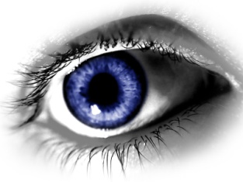C:\Users\DCS Laptop\AppData\Local\Microsoft\Windows\Temporary Internet Files\Content.IE5\Z5BK1XJO\MC900057385[1].wmf**

*The Ear, the Eye, and the Arm* follows many of the elements of a typical bildungsroman or coming of age story. Your task is to pick three of the elements of a bildungsroman and explain how they are used and what they teach through the book. In an organized, thesis driven, five-paragraph essay, argue what you believe the book teaches through your three examples.

**Your thesis should start like this:**

*The Ear, the Eye, and the Arm* is a bildungsroman that teaches (Come up with what you believe the book teaches through your examples chosen) through the (First one you will write about), (Second one you will write about), and (Third one you will write about) elements of a coming of age story.

**Make sure your thesis is the LAST SENTENCE of your introduction!**

The elements of a bildungsroman are as follows:

* Life changing death
* Down the Rabbit Hole
* Disagreement with parents
* Experimentation with rebellion
* Combat
* Hunting
* Growing up sucks

You must use **THREE QUOTES** from the book to support your ideas about what the book teaches. Make sure you cite your quotes as follows:

“ quote quote quote quote quote quote quote quote quote quote quote,” (page 3).

****Essays that do not include quotes will not receive higher than a C- on this paper. Many of you seem to think that when Mrs. Tolman says use quotes, she doesn’t mean it. She does!

Due Date: ______________